Twitter Thread: What pensions do teachers want?

James Zuccollo

March 21, 2025

Table of contents

## Tweet 1: Introduction

📊 NEW REPORT: “What pensions do teachers want?”

We surveyed 5,750 teachers on their compensation preferences. With teacher pay down 14% since 2010, could pension flexibility help with recruitment & retention?

Dwnload and read the full report: https://epi.org.uk/wp-content/uploads/2025/03/EPI-report-teachers-pension-flexibility-3.pdf

🧵 THREAD on our key findings… #Education #TeacherPensions

## Tweet 2: Salary vs Pension

Teachers value salary increases 1.6x more than pension increases. A 10% increase in retirement income is valued the same as a 6.3% salary increase. But pension remains highly valued - teachers aren’t dismissing retirement benefits.

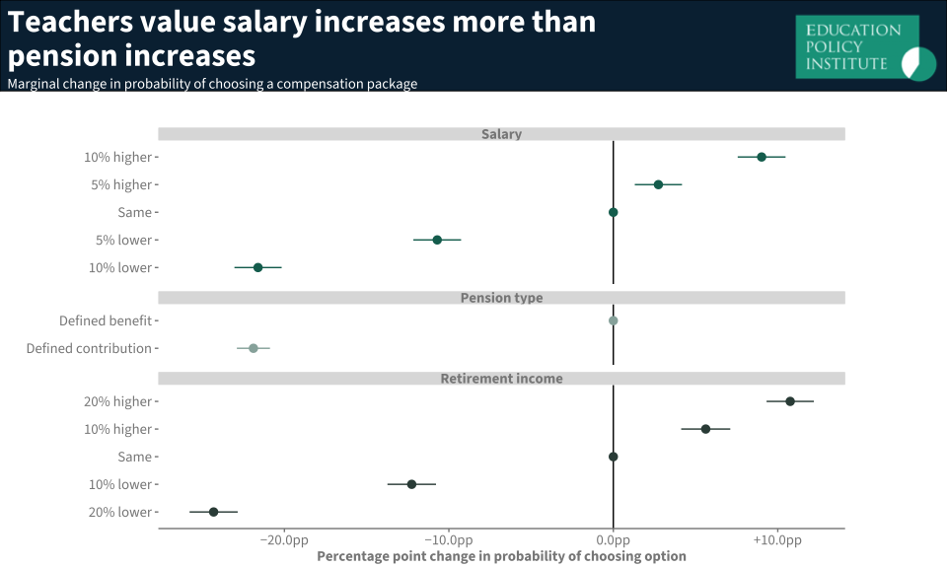

## Tweet 3: Loss Aversion

Teachers experience LOSS AVERSION - decreases in income hurt twice as much as gains help.

They’re 21 percentage points less likely to choose an option with a 10% salary cut, but only 9.1 percentage points more likely with a 10% increase. #BehaviouralEconomics

## Tweet 4: Guaranteed Income

Teachers STRONGLY prefer guaranteed retirement income.

Losing the certainty of a defined benefit pension, like the Teachers’ Pensions Scheme, is as disliked as a 10% salary cut.

## Tweet 5: Age Differences

Younger teachers care more about immediate salary than older colleagues.

Salary changes affect the wellbeing of teachers in their 20s about TWICE as much as teachers in their 50s. This age divide is why young teachers’ salaries are so important.

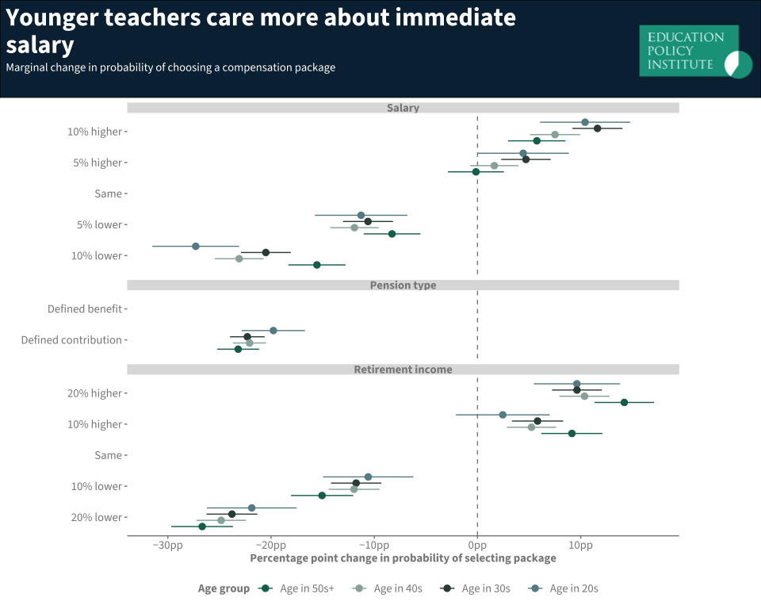

## Tweet 6: Financial Security

Teachers struggling to make ends meet care more about immediate salary than pension benefits. The effect is similar to age differences but less pronounced.

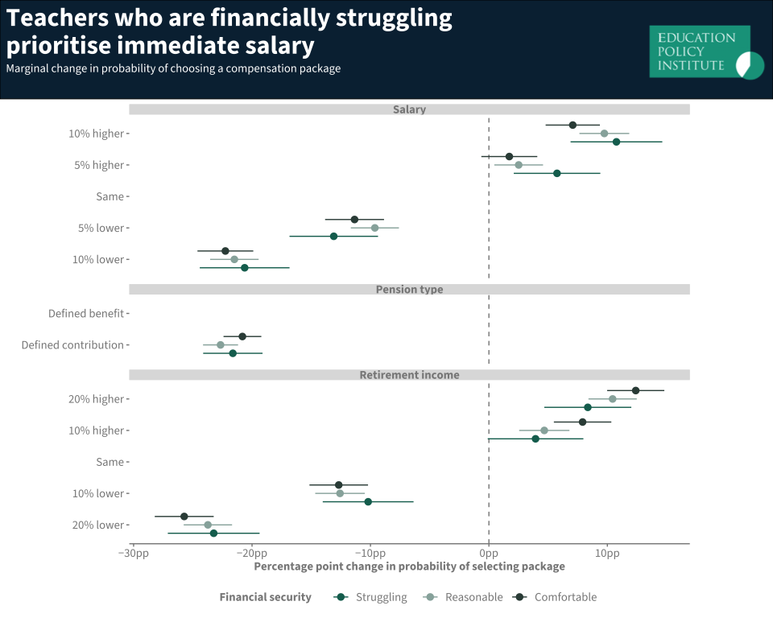

## Tweet 7: Simulation Results

When offered a 10% salary increase with a 20% pension reduction + DC scheme vs current TPS:

* 19% of teachers in their 20s would switch
* Only 11% of teachers in their 50s would switch

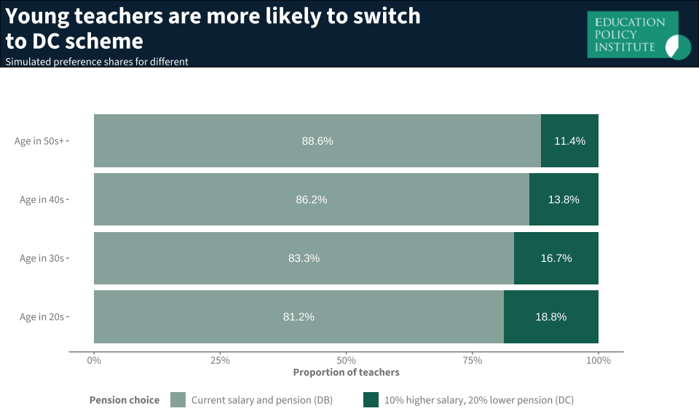

## Tweet 8: Key Recommendations

Our recommendations:

1️⃣ Continue allowing schools to offer multiple pension plans

2️⃣ Investigate flexibility within TPS (like Civil Service options)

3️⃣ Research impact on recruitment & retirement security